Task-1

University Scholarship Allocation: Design a system that evaluates applicants using aggregate marks, subject-wise minimum scores, attendance, and income criteria, ranks eligible students, and resolves ties using predefined rules.

1. Algorithm
- Start.
- Read the student's marks.
- Read the student's attendance percentage.
- Read the student's family income.
- Check whether marks are greater than or equal to 75.
- Check whether attendance is greater than or equal to 75%.
- Check whether family income is less than or equal to ₹2,00,000.
- If all three conditions are satisfied, display "Eligible for scholarship".
- Otherwise, display "Not eligible".
- Stop.

2. Flowchart
┌──────────────┐
│ START │
└──────┬───────┘
│
▼
┌────────────────────────┐
│ Enter Marks │
└───────────┬────────────┘
│
▼
┌────────────────────────┐
│ Enter Attendance │
└───────────┬────────────┘
│
▼
┌────────────────────────┐
│ Enter Family Income │
└───────────┬────────────┘
│
▼
┌─────────────────┐
│ Marks >= 75 ? │
└───────┬─────────┘
No │ Yes
│ │
▼ ▼
┌───────────┐ ┌──────────────────┐
│ NOT │ │ Attendance >=75? │
│ ELIGIBLE │ └────────┬─────────┘
└───────────┘ No │ Yes
│
▼
┌───────────┐
│ NOT │
│ ELIGIBLE │
└───────────┘
│
▼
┌─────────────────┐
│ Income <= 200000│
│ ? │
└───────┬─────────┘
No │ Yes
│
▼
┌──────────────┐
│ NOT │
│ ELIGIBLE │
└──────────────┘
│
▼
┌──────────────────┐
│ ELIGIBLE │
│ FOR SCHOLARSHIP│
└────────┬─────────┘
│
▼
┌──────────┐
│ STOP │
└──────────┘

3. Pseudocode
START

INPUT marks
INPUT attendance
INPUT income

IF marks >= 75 AND attendance >= 75 AND income <= 200000 THEN
DISPLAY "Eligible for scholarship"
ELSE
DISPLAY "Not eligible"
END IF

STOP

4. Test Cases
Test Case | Marks | Attendance | Income | Expected Output
1 | 80 | 85% | ₹150000 | Eligible
2 | 70 | 85% | ₹150000 | Not Eligible
3 | 80 | 70% | ₹150000 | Not Eligible
4 | 80 | 85% | ₹250000 | Not Eligible
5 | 75 | 75% | ₹200000 | Eligible
6 | 74 | 74% | ₹210000 | Not Eligible

Test Case 1
Input:
Marks = 80
Attendance = 85
Income = 150000
Output:
Eligible for scholarship

Test Case 2
Input:
Marks = 70
Attendance = 85
Income = 150000
Output:
Not eligible

Test Case 3
Input:
Marks = 80
Attendance = 70
Income = 150000
Output:
Not eligible

Test Case 4
Input:
Marks = 80
Attendance = 85
Income = 250000
Output:
Not eligible

Test Case 5 – Boundary Values
Input:
Marks = 75
Attendance = 75
Income = 200000
Output:
Eligible for scholarship

5. Conclusion
The University Scholarship Allocation System successfully determines whether a student is eligible for a scholarship based on marks, attendance, and family income. The program uses conditional statements to check all the required criteria. If all conditions are satisfied, the student is declared eligible; otherwise, the student is declared not eligible. This makes the scholarship selection process simple, fast, and consistent.

6.Programm
marks = int(input("Enter marks: "))
attendance = int(input("Enter attendance: "))
income = int(input("Enter family income: "))

if marks >= 75 and attendance >= 75 and income <= 200000:
print("Eligible for scholarship")
else:
print("Not eligible")

7.Screenshot
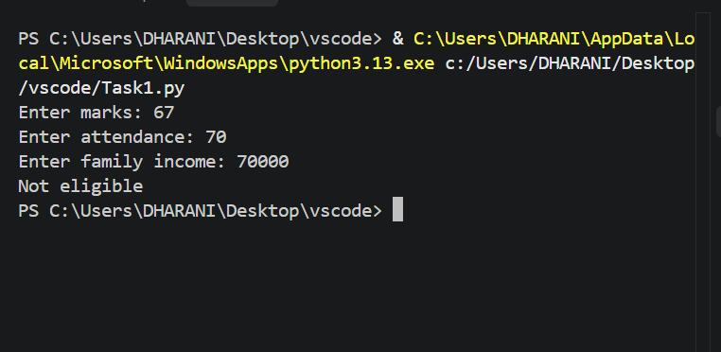

Task-2
Progressive Electricity Billing: Calculate household bills using multiple consumption slabs, fixed charges, surcharges, and rebates, then compare bills across several months and identify unusual increases.

1. Algorithm
- Start
- Enter the number of electricity units consumed.
- If units are less than or equal to 100:
  - Calculate bill = units × 2.
- Else if units are less than or equal to 200:
  - Calculate bill = 100 × 2 + (units − 100) × 3.
- Otherwise:
  - Calculate bill = 100 × 2 + 100 × 3 + (units − 200) × 5.
- Display the calculated electricity bill.
- Stop

2. Flowchart
┌─────────────┐
│ START │
└──────┬──────┘
│
▼
┌──────────────────┐
│ Enter Units │
└────────┬─────────┘
│
▼
┌───────────────┐
│ Units <= 100?│
└──────┬────────┘
Yes│
▼
┌──────────────────┐
│ Bill = Units × 2 │
└────────┬─────────┘
│
│
▼
┌───────────────┐
│ Units <= 200?│
└──────┬────────┘
Yes │ No
│
┌─────────▼──────────────┐
│ Bill = 100×2 + │
│ (Units-100)×3 │
└─────────┬──────────────┘
│
│
▼
┌────────────────────────┐
│ Bill = 100×2 + 100×3 + │
│ (Units-200)×5 │
└───────────┬────────────┘
│
▼
┌─────────────────┐
│ Display Bill │
└────────┬────────┘
│
▼
┌───────────┐
│ STOP │
└───────────┘

3. Pseudocode
START

INPUT units

IF units <= 100 THEN
bill = units * 2

ELSE IF units <= 200 THEN
bill = 100 * 2 + (units - 100) * 3

ELSE
bill = 100 * 2 + 100 * 3 + (units - 200) * 5

END IF

DISPLAY "Electricity bill =", bill

STOP

4. Test Cases
Test Case | Input (Units) | Calculation | Expected Output
1 | 50 | 50 × 2 | ₹100
2 | 100 | 100 × 2 | ₹200
3 | 150 | (100×2) + (50×3) | ₹350
4 | 200 | (100×2) + (100×3) | ₹500
5 | 250 | (100×2) + (100×3) + (50×5) | ₹750
6 | 300 | (100×2) + (100×3) + (100×5) | ₹1000

Test Case 1
Input:
Units = 50
Output:
Electricity bill = 100

Test Case 2
Input:
Units = 150
Output:
Electricity bill = 350

Test Case 3
Input:
Units = 250
Output:
Electricity bill = 750

5. Conclusion
The Progressive Electricity Billing System calculates the electricity bill based on the number of units consumed. It applies different rates to different consumption slabs using conditional statements. The system provides an efficient and simple method for calculating electricity charges accurately.

6.Programm
units = int(input("Enter units: "))

if units <= 100:
bill = units * 2
elif units <= 200:
bill = 100 * 2 + (units - 100) * 3
else:
bill = 200 * 5 + (units - 200) * 5

print("Electricity bill =", bill)

7.Screenshot
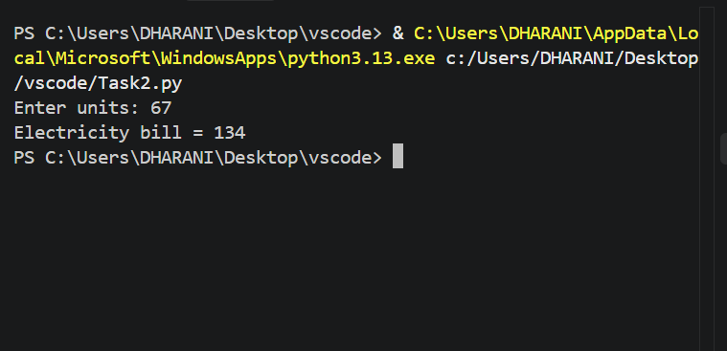

Task-3
Employee Payroll and Deduction Analysis: Calculate gross salary from basic pay, allowances, overtime, and incentives; apply progressive deductions and generate a formatted salary statement.

1. Algorithm
- Start.
- Read the distance travelled in kilometres.
- Read the passenger's age.
- Calculate the basic fare:
  - fare = distance × 2
- Check whether the passenger's age is less than 12.
- If age is less than 12, calculate half fare:
  - fare = fare ÷ 2
- Display the railway fare.
- Stop.

2. Flowchart
┌─────────────┐
│ START │
└──────┬──────┘
│
▼
┌───────────────────┐
│ Enter distance │
│ Enter age │
└────────┬──────────┘
│
▼
┌───────────────────┐
│ fare = distance×2 │
└────────┬──────────┘
│
▼
┌─────────────┐
│ age < 12? │
└──────┬──────┘
Yes │ │ No
│ │
▼ │
┌──────────┐ │
│fare=fare │ │
│ / 2 │ │
└────┬─────┘ │
│ │
└───┬───┘
▼
┌────────────────┐
│ Display fare │
└───────┬────────┘
│
▼
┌─────────────┐
│ STOP │
└─────────────┘

3. Pseudocode
BEGIN

INPUT distance
INPUT age

fare ← distance × 2

IF age < 12 THEN
fare ← fare ÷ 2
END IF

DISPLAY "Railway fare =", fare

END

4. Test Cases
Test Case | Distance (km) | Age | Expected Fare
1 | 10 | 25 | 20
2 | 20 | 10 | 20
3 | 50 | 12 | 100
4 | 100 | 8 | 100
5 | 5 | 30 | 10
Explanation:
- For adults (age 12 or above), fare = distance × 2.
- For children below 12, the fare is reduced to half.

5. Conclusion
The program successfully calculates railway fare based on the travel distance and passenger age. It applies a 50% discount for children below 12 years and displays the final fare. The program demonstrates the use of input, arithmetic operations, conditional statements, and output in Python.

6.Programm
distance = int(input("Enter distance in km: "))
age = int(input("Enter age: "))

fare = distance * 2

if age < 12:
fare = fare / 2

print("Railway fare =", fare)

7.Screenshot
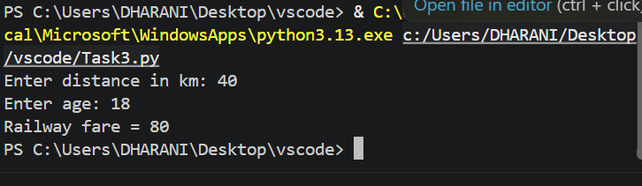

Task-4
Railway Fare and Reservation Calculator: Calculate fares for multiple passengers using distance slabs, travel classes, age-based concessions, reservation fees, and specified cancellation penalties

1. Algorithm
- Start
- Input the number of passengers n.
- Repeat the following steps for each passenger:
  - Input the passenger's age.
  - Input the distance travelled.
  - Input the travel class (Sleeper/AC).
  - Calculate the basic fare based on distance:
    - If distance ≤ 100 km: fare = distance × 1
    - If distance ≤ 500 km: fare = 100 + (distance - 100) × 1.5
    - Otherwise: fare = 700 + (distance - 500) × 2
  - If the class is AC, multiply the fare by 2.
  - Apply age concession:
    - Age < 12 → 50% of fare.
    - Age ≥ 60 → 80% of fare.
    - Otherwise → no concession.
  - Add the reservation fee of ₹50.
  - Display the ticket fare.
  - Ask whether the passenger wants to cancel the ticket.
  - If cancellation is "yes", calculate the refund as 80% of the fare.
  - Display the refund.
- Repeat until all passengers are processed.
- Stop

2. Flowchart
┌───────────────┐
│ START │
└───────┬───────┘
│
▼
┌──────────────────────┐
│ Enter number of │
│ passengers (n) │
└──────────┬───────────┘
│
▼
┌───────────┐
│ i = 1 │
└─────┬─────┘
│
▼
┌───────────────┐
│ i <= n ? │
└──────┬────────┘
Yes │ │ No
│ ▼
│ ┌──────────┐
│ │ STOP │
│ └──────────┘
▼
┌─────────────────────────┐
│ Enter age, distance, │
│ travel class │
└────────────┬────────────┘
│
▼
┌─────────────────┐
│ Distance <= 100?│
└───────┬─────────┘
Yes │ │ No
│ ▼
│ ┌─────────────────┐
│ │ Distance <=500? │
│ └───────┬─────────┘
│ Yes │ │ No
│ │ │
▼ ▼ ▼
┌────────┐ ┌──────────────┐
│fare = │ │fare = 100 + │
│distance│ │(distance-100)│
│ × 1 │ │× 1.5 │
└───┬────┘ └───────┬──────┘
│ │
│ │
│ ┌────▼─────────────┐
│ │ fare = 700 + │
│ │(distance-500)×2 │
│ └──────┬───────────┘
└───────────┬─────┘
│
▼
┌──────────────────┐
│ Class = AC ? │
└────────┬─────────┘
Yes │ │ No
▼ │
┌──────────────┐
│ fare = fare×2 │
└──────┬───────┘
│
▼
┌─────────────────┐
│ Age < 12 ? │
└───────┬─────────┘
Yes │ │ No
▼ ▼
┌────────────┐ ┌──────────────┐
│fare=fare×.5│ │ Age >= 60 ? │
└─────┬──────┘ └──────┬───────┘
│ Yes │ │ No
│ ▼ │
│ ┌────────────┐
│ │fare=fare×.8 │
│ └─────┬──────┘
└────────┬───┘
▼
┌────────────────┐
│ fare = fare+50 │
└───────┬────────┘
│
▼
┌────────────────┐
│ Display fare │
└───────┬────────┘
│
▼
┌────────────────┐
│ Cancel ticket? │
└───────┬────────┘
Yes │ │ No
▼ │
┌────────────────────┐
│ Refund = fare×0.8 │
└─────────┬──────────┘
│
▼
┌────────────────────┐
│ Display refund │
└─────────┬──────────┘
│
▼
┌──────────┐
│ i = i + 1│
└────┬─────┘
│
└──────► Repeat

3. Pseudocode
BEGIN

INPUT n

FOR i ← 1 TO n DO

INPUT age
INPUT distance
INPUT travel_class

IF distance <= 100 THEN
fare ← distance × 1

ELSE IF distance <= 500 THEN
fare ← 100 + (distance - 100) × 1.5

ELSE
fare ← 700 + (distance - 500) × 2
END IF

IF travel_class = "AC" THEN
fare ← fare × 2
END IF

IF age < 12 THEN
fare ← fare × 0.5

ELSE IF age >= 60 THEN
fare ← fare × 0.8
END IF

fare ← fare + 50

DISPLAY "Ticket fare =", fare

INPUT cancel

IF cancel = "yes" THEN
refund ← fare × 0.8
DISPLAY "Refund =", refund
END IF

END FOR

END

4. Test Cases
Test Case | Age | Distance | Class | Cancellation | Expected Fare | Expected Refund
1 | 30 | 50 km | sleeper | no | ₹100 | —
2 | 30 | 200 km | sleeper | no | ₹250 | —
3 | 30 | 600 km | sleeper | no | ₹950 | —
4 | 10 | 100 km | sleeper | no | ₹100 | —
5 | 65 | 200 km | sleeper | yes | ₹210 | ₹168
6 | 30 | 100 km | AC | yes | ₹250 | ₹200
7 | 8 | 200 km | AC | yes | ₹250 | ₹200
8 | 70 | 600 km | AC | no | ₹1,570 | —

Sample calculations
Test Case 2:
- Distance = 200 km
- Fare = 100 + (200 - 100) × 1.5
- Fare = ₹250
- Reservation fee = ₹50
- Total = ₹300
Correction: The code adds ₹50 after calculating the fare, so the expected fare for Test Case 2 is ₹300, not ₹250.
Therefore, the corrected important test cases are:
Test Case | Age | Distance | Class | Cancellation | Correct Fare | Refund
1 | 30 | 50 km | sleeper | no | ₹100 | —
2 | 30 | 200 km | sleeper | no | ₹300 | —
3 | 30 | 600 km | sleeper | no | ₹1000 | —
4 | 10 | 100 km | sleeper | no | ₹100 | —
5 | 65 | 200 km | sleeper | yes | ₹250 | ₹200
6 | 30 | 100 km | AC | yes | ₹250 | ₹200
7 | 8 | 200 km | AC | yes | ₹300 | ₹240
8 | 70 | 600 km | AC | no | ₹1,570 | —

5. Conclusion
The Railway Fare and Reservation Calculator successfully calculates the ticket fare for multiple passengers by considering distance slabs, travel class, age-based concessions, and reservation charges. It also calculates the refund amount when a ticket is cancelled, using an 80% refund rate. The program demonstrates the use of loops, conditional statements, arithmetic operations, user input, and formatted output in Python.

6.Programm
n = int(input("Enter number of passengers: "))

for i in range(n):
age = int(input("Enter age: "))
distance = int(input("Enter distance: "))
travel_class = input("Enter class (sleeper/AC): ")

if distance <= 100:
fare = distance * 1
elif distance <= 500:
fare = 100 + (distance - 100) * 1.5
else:
fare = 700 + (distance - 500) * 2

if travel_class == "AC":
fare = fare * 2

if age < 12:
fare = fare * 0.5
elif age >= 60:
fare = fare * 0.8

fare = fare + 50
print("Ticket fare =", fare)

cancel = input("Cancel ticket? (yes/no): ")
if cancel == "yes":
print("Refund =", fare * 0.8)

7.Screenshot
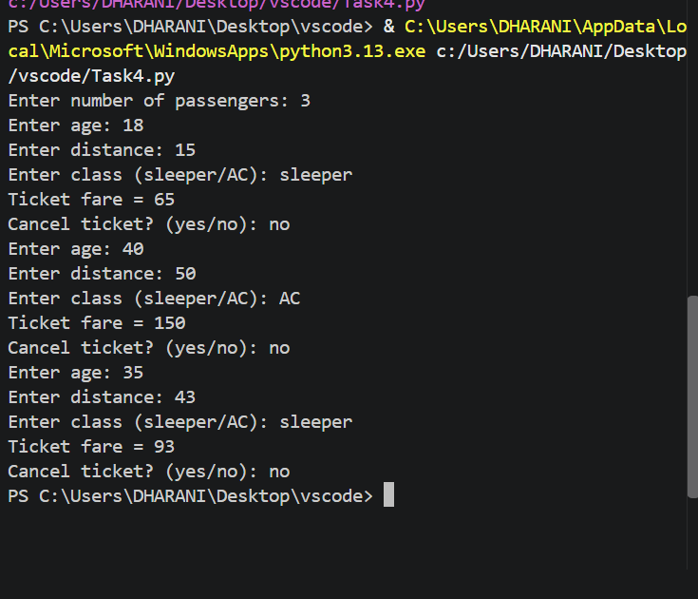

Task-5
Retail Billing with Multiple Discount Rules: Process multiple products, quantities, categoryspecific taxes, threshold discounts, and maximum concession limits to generate an itemized invoice

1. Algorithm
- Start
- Input the number of products n.
- Initialize total = 0.
- Repeat the following steps for each product:
  - Enter the product name.
  - Enter the price.
  - Enter the quantity.
  - Enter the category (food or other).
  - Calculate the product amount:
    - amount = price × quantity
  - Apply category-specific tax:
    - If category is food, add 5% tax.
    - Otherwise, add 10% tax.
  - Add the calculated amount to total.
  - Display the product name and amount.
- Initialize discount = 0.
- Check whether total >= 2000.
  - If yes, calculate 10% discount.
- Check whether the discount is greater than ₹500.
  - If yes, limit the discount to ₹500.
- Calculate the final bill:
  - final_bill = total - discount
- Display the total bill.
- Stop.

2. Flowchart
┌──────────────┐
│ START │
└──────┬───────┘
│
▼
┌─────────────────────┐
│ Enter number of │
│ products (n) │
└──────────┬──────────┘
│
▼
┌─────────────┐
│ total = 0 │
│ i = 1 │
└──────┬──────┘
│
▼
┌─────────────┐
│ i <= n ? │
└──────┬──────┘
Yes │ │ No
│ │
│ ▼
│ ┌────────────────┐
│ │ discount = 0 │
│ └───────┬────────┘
│ │
▼ │
┌──────────────────┐ │
│ Enter name, │ │
│ price, qty, │ │
│ category │ │
└────────┬─────────┘ │
│ │
▼ │
┌──────────────────┐ │
│ amount = │ │
│ price × quantity │ │
└────────┬─────────┘ │
│ │
▼ │
┌──────────────────┐ │
│ category = food? │ │
└───────┬──────────┘ │
Yes │ │ No │
│ │ │
▼ ▼ │
┌────────┐ ┌────────┐
│ Add 5% │ │ Add 10%│
│ tax │ │ tax │
└───┬────┘ └───┬────┘
│ │
└─────┬──────┘
│
▼
┌──────────────────┐
│ total = total + │
│ amount │
└────────┬─────────┘
│
▼
┌──────────────────┐
│ Display product │
│ amount │
└────────┬─────────┘
│
▼
┌───────────┐
│ i = i + 1 │
└─────┬─────┘
│
└──────────► Repeat
│
▼
┌────────────────┐
│ total >= 2000? │
└───────┬────────┘
Yes │ │ No
│ │
▼ │
┌─────────────────┐
│ discount = │
│ total × 10% │
└────────┬────────┘
│
▼
┌─────────────────┐
│ discount > 500? │
└────────┬────────┘
Yes │ │ No
▼ │
┌───────────────┐ │
│ discount=500 │ │
└───────┬───────┘ │
└────┬─────┘
│
▼
┌──────────────────┐
│ Final Bill = │
│ total - discount │
└────────┬─────────┘
│
▼
┌──────────────────┐
│ Display Total │
│ Bill │
└────────┬─────────┘
│
▼
┌──────────┐
│ STOP │
└──────────┘

3. Pseudocode
BEGIN

INPUT n
total ← 0

FOR i ← 1 TO n DO

INPUT name
INPUT price
INPUT quantity
INPUT category

amount ← price × quantity

IF category = "food" THEN
amount ← amount + (amount × 0.05)
ELSE
amount ← amount + (amount × 0.10)
END IF

total ← total + amount

DISPLAY name, "Amount =", amount

END FOR

discount ← 0

IF total >= 2000 THEN
discount ← total × 0.10
END IF

IF discount > 500 THEN
discount ← 500
END IF

final_bill ← total - discount

DISPLAY "Total bill =", final_bill

END

4. Test Cases
Test Case | Product | Price | Qty | Category | Tax | Total Before Discount | Discount | Final Bill
1 | Rice | ₹500 | 2 | food | 5% | ₹1050 | ₹0 | ₹1050
2 | Shirt | ₹1000 | 2 | other | 10% | ₹2200 | ₹220 | ₹1980
3 | Milk | ₹1000 | 2 | food | 5% | ₹2100 | ₹210 | ₹1890
4 | Laptop | ₹6000 | 1 | other | 10% | ₹6600 | ₹500* | ₹6100
5 | Biscuit | ₹100 | 1 | food | 5% | ₹105 | ₹0 | ₹105
* The calculated discount is ₹660, but the maximum concession is limited to ₹500.

Sample calculation for Test Case 2
- Price = ₹1000
- Quantity = 2
- Basic amount = 1000 × 2 = ₹2000
- 10% tax = ₹200
- Total = ₹2200
- Since total ≥ ₹2000:
  - Discount = 10% of ₹2200 = ₹220
- Final bill = ₹2200 - ₹220 = ₹1980

5. Conclusion
The Retail Billing program successfully processes multiple products and quantities, calculates category-specific taxes, and applies a 10% threshold discount when the bill reaches ₹2000 or more. It also ensures that the discount does not exceed the maximum concession of ₹500. The program demonstrates the use of loops, conditional statements, arithmetic operations, tax calculations, and discount rules to generate an itemized retail bill.

6.Programm
n = int(input("Enter number of products: "))
total = 0

for i in range(n):
name = input("Enter product name: ")
price = float(input("Enter price: "))
qty = int(input("Enter quantity: "))
category = input("Enter category (food/other): ")

amount = price * qty

if category == "food":
amount = amount + amount * 0.05
else:
amount = amount + amount * 0.10

total = total + amount
print(name, "Amount =", amount)

discount = 0
if total >= 2000:
discount = total * 0.10

if discount > 500:
discount = 500

print("Total bill =", total - discount)

7.Screenshot
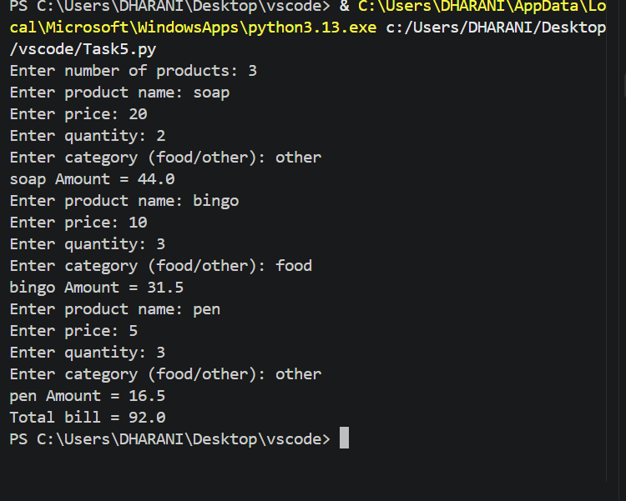

Task-6
Examination Result and Grace-Mark Validation: Process marks across multiple subjects, apply subject-wise pass criteria and a specified grace-mark policy, and generate final classifications without exceeding maximum marks.

1. Algorithm
- Start.
- Input the number of subjects n.
- Create an empty list called marks.
- Repeat for each subject:
  - Input the marks obtained.
  - Store the marks in the list.
  - If marks are between 30 and 34, add 5 grace marks.
  - If the resulting marks exceed 100, set them to 100.
- Display the final marks for all subjects.
- Check whether all subjects have at least 35 marks:
  - If yes, display PASS.
  - Otherwise, display FAIL.
- Calculate the total marks.
- Calculate the average marks.
- Display the total and average.
- Stop.

2. Flowchart
┌──────────────┐
│ START │
└──────┬───────┘
│
▼
┌─────────────────────┐
│ Enter number of │
│ subjects (n) │
└──────────┬──────────┘
│
▼
┌─────────────┐
│ marks = [] │
│ i = 1 │
└──────┬──────┘
│
▼
┌─────────────┐
│ i <= n ? │
└──────┬──────┘
Yes │ │ No
│ │
│ ▼
│ ┌─────────────────┐
│ │ Display final │
│ │ marks │
│ └────────┬────────┘
│ │
▼ │
┌──────────────────┐ │
│ Enter subject │ │
│ marks │ │
└────────┬─────────┘ │
│ │
▼ │
┌──────────────────┐ │
│ Store marks │ │
└────────┬─────────┘ │
│ │
▼ │
┌──────────────────┐ │
│ 30 <= marks < 35?│ │
└────────┬─────────┘ │
Yes │ │ No │
▼ │ │
┌──────────────┐ │
│ Add 5 grace │ │
│ marks │ │
└──────┬───────┘ │
│ │
└──────┬───────┘
▼
┌────────────────┐
│ Marks > 100 ? │
└───────┬────────┘
Yes │ │ No
▼ │
┌──────────┐│
│ marks=100││
└─────┬────┘│
└──┬───┘
▼
┌────────────┐
│ i = i + 1 │
└─────┬──────┘
│
└──────► Repeat
│
▼
┌──────────────────┐
│ Are all marks │
│ >= 35 ? │
└────────┬─────────┘
Yes │ │ No
│ │
┌───────▼┐ ┌▼──────────┐
│ PASS │ │ FAIL │
└────┬───┘ └────┬─────┘
└──────┬────┘
▼
┌─────────────────┐
│ Calculate total │
│ and average │
└────────┬────────┘
│
▼
┌─────────────────┐
│ Display total │
│ and average │
└────────┬────────┘
│
▼
┌─────────┐
│ STOP │
└─────────┘

3. Pseudocode
BEGIN

INPUT n
marks ← empty list

FOR i ← 1 TO n DO

INPUT m
ADD m TO marks

IF m < 35 AND m >= 30 THEN
marks[i] ← m + 5
END IF

IF marks[i] > 100 THEN
marks[i] ← 100
END IF

END FOR

DISPLAY "Final marks:", marks

IF all marks >= 35 THEN
DISPLAY "Result: PASS"
ELSE
DISPLAY "Result: FAIL"
END IF

total ← SUM of marks
average ← total / n

DISPLAY "Total marks =", total
DISPLAY "Average =", average

END

4. Test Cases
Test Case | Number of Subjects | Input Marks | Final Marks | Result | Total | Average
1 | 3 | 80, 75, 90 | 80, 75, 90 | PASS | 245 | 81.67
2 | 3 | 30, 75, 90 | 35, 75, 90 | PASS | 200 | 66.67
3 | 3 | 29, 80, 90 | 29, 80, 90 | FAIL | 199 | 66.33
4 | 4 | 34, 33, 80, 90 | 39, 38, 80, 90 | PASS | 247 | 61.75
5 | 3 | 100, 34, 35 | 100, 39, 35 | PASS | 174 | 58.00

Grace-Mark Example
For marks 30:
- Original mark = 30
- Since 30 >= 30 and 30 < 35, add 5 grace marks.
- Final mark = 35
- The student passes that subject.
For marks 29:
- 29 is below 30.
- No grace marks are awarded.
- Final mark = 29
- Since 29 < 35, the overall result is FAIL.

Maximum-Mark Validation
If a mark somehow becomes greater than 100 after adding grace marks, the program sets it to 100, ensuring that the final mark never exceeds the maximum possible mark.

5. Conclusion
The Examination Result and Grace-Mark Validation program successfully processes marks for multiple subjects and applies a 5-mark grace policy to students scoring between 30 and 34 marks. It ensures that marks never exceed the maximum of 100, determines the overall PASS or FAIL result, and calculates the total and average marks. The program demonstrates the use of loops, lists, conditional statements, grace-mark rules, validation, and aggregate calculations in Python.

6.Programm
n = int(input("Enter number of subjects: "))
marks = []

for i in range(n):
m = int(input("Enter subject marks: "))
marks.append(m)

if m < 35 and m >= 30:
marks[i] = m + 5

if marks[i] > 100:
marks[i] = 100

print("Final marks:", marks)

if all(m >= 35 for m in marks):
print("Result: PASS")
else:
print("Result: FAIL")

total = sum(marks)
average = total / n

print("Total marks =", total)
print("Average =", average)

7.Screenshot
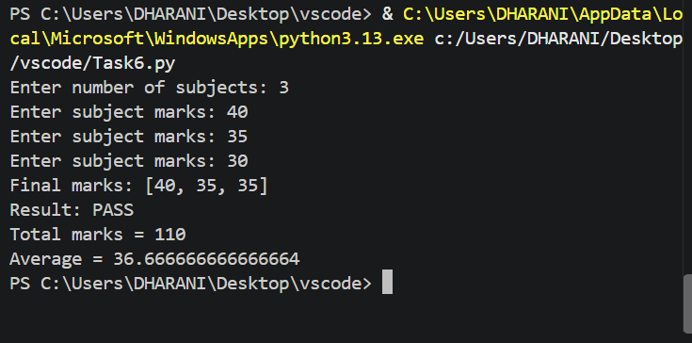

Task-7
Attendance Recovery Computation: Calculate current attendance percentages and determine the minimum consecutive classes required to reach an eligibility threshold under different future attendance scenarios.

1. Algorithm
- Start.
- Input the number of classes attended.
- Input the total number of classes.
- Input the required attendance percentage.
- Calculate the current attendance percentage:
  - percentage = (attended / total) × 100
- Display the current attendance percentage.
- Check whether the current attendance is greater than or equal to the required percentage.
  - If yes, display "Already eligible".
- Otherwise, initialize needed = 0.
- Check whether the attendance after attending needed additional consecutive classes reaches the target:
  - (attended + needed) / (total + needed) × 100
- If it is below the target, increase needed by 1.
- Repeat the calculation until the target attendance is reached.
- Display the minimum number of classes needed.
- Stop.

2. Flowchart
┌──────────────┐
│ START │
└──────┬───────┘
│
▼
┌────────────────────────┐
│ Enter attended classes │
│ Enter total classes │
│ Enter target % │
└───────────┬────────────┘
│
▼
┌─────────────────────────┐
│ percentage = │
│ attended/total × 100 │
└───────────┬─────────────┘
│
▼
┌─────────────────────────┐
│ Display current │
│ attendance │
└───────────┬─────────────┘
│
▼
┌──────────────┐
│ percentage │
│ >= target ? │
└──────┬───────┘
Yes │ │ No
│ │
▼ ▼
┌──────────────┐ ┌──────────────┐
│ Already │ │ needed = 0 │
│ eligible │ └──────┬───────┘
└──────┬───────┘ │
│ ▼
│ ┌────────────────────┐
│ │ Calculate attendance│
│ │ with needed classes │
│ └─────────┬──────────┘
│ │
│ ▼
│ ┌────────────────────┐
│ │ Attendance < │
│ │ target ? │
│ └─────────┬──────────┘
│ Yes │ │ No
│ │ │
│ ▼ │
│ ┌────────────────┐
│ │ needed=needed+1│
│ └───────┬────────┘
│ │
│ └──────► Repeat
│
▼
┌──────────────────┐
│ Display classes │
│ needed │
└────────┬─────────┘
│
▼
┌──────────┐
│ STOP │
└──────────┘

3. Pseudocode
BEGIN

INPUT attended
INPUT total
INPUT target

percentage ← (attended / total) × 100

DISPLAY "Current attendance =", percentage

IF percentage >= target THEN

DISPLAY "Already eligible"

ELSE

needed ← 0

WHILE ((attended + needed) /
(total + needed)) × 100 < target DO

needed ← needed + 1

END WHILE

DISPLAY "Classes needed =", needed

END IF

END

4. Test Cases
Test Case | Classes Attended | Total Classes | Target % | Current Attendance | Expected Output
1 | 80 | 100 | 75% | 80% | Already eligible
2 | 60 | 100 | 75% | 60% | 60 classes needed
3 | 70 | 100 | 75% | 70% | 20 classes needed
4 | 90 | 100 | 75% | 90% | Already eligible
5 | 50 | 100 | 75% | 50% | 100 classes needed
6 | 74 | 100 | 75% | 74% | 4 classes needed

Sample Calculation – Test Case 3
Given:
- Classes attended = 70
- Total classes = 100
- Required attendance = 75%
Current attendance:
70 / 100 × 100 = 70%
The student is below the required 75%.
After attending 20 more classes:
(70 + 20) / (100 + 20) × 100
= 90 / 120 × 100
= 75%
Therefore, 20 additional consecutive classes are required.

Sample Calculation – Test Case 6
- Attended = 74
- Total = 100
- Target = 75%
After 4 additional classes:
(74 + 4) / (100 + 4) × 100
= 78 / 104 × 100
= 75%
Therefore, 4 classes are needed.

5. Conclusion
The Attendance Recovery Computation program calculates the student's current attendance percentage and determines the minimum number of consecutive classes that must be attended to reach the required eligibility percentage. If the student already meets the target, the program displays "Already eligible". The program demonstrates the use of input, arithmetic calculations, conditional statements, and while loops to solve an attendance recovery problem efficiently.

6.Programm
attended = int(input("Enter classes attended: "))
total = int(input("Enter total classes: "))
target = int(input("Enter required attendance percentage: "))

percentage = attended / total * 100
print("Current attendance =", percentage, "%")

if percentage >= target:
print("Already eligible")
else:
needed = 0

while (attended + needed) / (total + needed) * 100 < target:
needed = needed + 1

print("Classes needed =", needed)

7.Screenshot
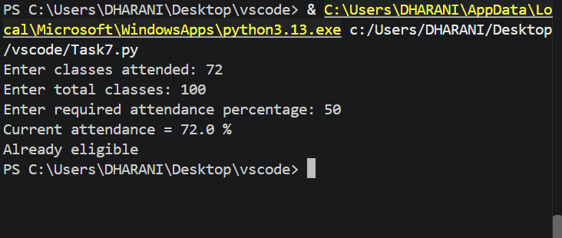

Task-8
ATM Transaction Sequence Simulation: Process a sequence of deposits and withdrawals, maintain a simulated balance, enforce withdrawal limits, reject invalid transactions, and produce a transaction summary.

1. Algorithm
- Start.
- Initialize the account balance to ₹5000.
- Input the transaction amount.
- Input the transaction type: deposit or withdraw.
- If the choice is deposit:
  - Add the amount to the balance.
- Else, if the choice is withdraw and the amount is less than or equal to the current balance:
  - Subtract the amount from the balance.
- Otherwise:
  - Display "Invalid transaction".
- Display the updated balance.
- Stop.
Note: The given code checks the withdrawal against the available balance, but it does not enforce a separate maximum withdrawal limit or process multiple transactions. The algorithm below follows the supplied code exactly.

2. Flowchart
┌──────────────┐
│ START │
└──────┬───────┘
│
▼
┌────────────────┐
│ balance = 5000 │
└───────┬────────┘
│
▼
┌───────────────────┐
│ Enter amount │
│ Enter transaction │
│ type │
└─────────┬─────────┘
│
▼
┌───────────────┐
│ choice = │
│ "deposit"? │
└───────┬───────┘
Yes │ │ No
│ │
▼ ▼
┌──────────────┐ ┌────────────────────┐
│ balance = │ │ choice = "withdraw"│
│ balance+amt │ │ AND amount<=balance│
└──────┬───────┘ └─────────┬──────────┘
│ Yes │ │ No
│ │ │
│ ▼ ▼
│ ┌───────────────┐
│ │ balance = │
│ │ balance-amount│
│ └───────┬───────┘
│ │
│ │
│ ┌────▼────────────┐
│ │ Invalid │
│ │ transaction │
│ └────┬────────────┘
│ │
└──────────┬────────┘
▼
┌────────────────┐
│ Display │
│ balance │
└───────┬────────┘
│
▼
┌──────────┐
│ STOP │
└──────────┘

3. Pseudocode
BEGIN

balance ← 5000

INPUT amount
INPUT choice

IF choice = "deposit" THEN
balance ← balance + amount

ELSE IF choice = "withdraw" AND amount <= balance THEN
balance ← balance - amount

ELSE
DISPLAY "Invalid transaction"

END IF

DISPLAY "Balance =", balance

END

4. Test Cases
Test Case | Initial Balance | Transaction | Amount | Expected Output
1 | ₹5000 | deposit | ₹2000 | Balance = ₹7000
2 | ₹5000 | withdraw | ₹1000 | Balance = ₹4000
3 | ₹5000 | withdraw | ₹5000 | Balance = ₹0
4 | ₹5000 | withdraw | ₹6000 | Invalid transaction, Balance = ₹5000
5 | ₹5000 | transfer | ₹1000 | Invalid transaction, Balance = ₹5000
6 | ₹5000 | deposit | ₹500 | Balance = ₹5500

Sample Test Case 1
Input:
Amount = 2000
Choice = deposit
Calculation:
5000 + 2000 = 7000
Output:
Balance = 7000

Sample Test Case 4
Input:
Amount = 6000
Choice = withdraw
Since ₹6000 is greater than the available balance of ₹5000, the withdrawal is rejected.
Output:
Invalid transaction
Balance = 5000

5. Conclusion
The ATM Transaction Simulation program maintains a simulated account balance and processes either a deposit or withdrawal transaction. Deposits increase the balance, while withdrawals are accepted only when the requested amount does not exceed the available balance. Invalid transactions are rejected and the balance remains unchanged. The program demonstrates conditional statements, arithmetic operations, input validation, and balance management in Python.

6.Programm
balance = 5000

amount = int(input("Enter amount: "))
choice = input("Enter deposit or withdraw: ")

if choice == "deposit":
balance = balance + amount
elif choice == "withdraw" and amount <= balance:
balance = balance - amount
else:
print("Invalid transaction")

print("Balance =", balance)

7.Screenshot
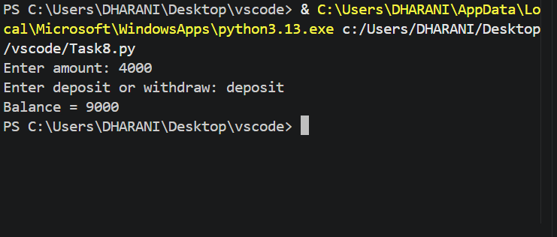

Task-9
Student Marks Matrix Analysis: Analyse a matrix of student marks across subjects, calculate row-wise and column-wise statistics, identify top performers, and detect subjects with low average performance.

1. Algorithm
- Start.
- Input the number of students n.
- Create an empty matrix called marks.
- For each student:
  - Create an empty row.
  - Input marks for 3 subjects.
  - Store the three marks in the row.
  - Add the row to the marks matrix.
- Create an empty list called totals.
- For each student's row:
  - Calculate the total marks using sum(row).
  - Store the total in totals.
  - Calculate the student's average.
  - Display the total and average.
- Find the highest total using max(totals).
- Find the student number having the highest total.
- For each of the 3 subjects:
  - Calculate the average marks of that subject across all students.
  - Display the subject average.
  - If the average is less than 35, display a low-performance warning.
- Stop.

2. Flowchart
┌──────────────┐
│ START │
└──────┬───────┘
│
▼
┌─────────────────────┐
│ Enter number of │
│ students (n) │
└──────────┬──────────┘
│
▼
┌────────────┐
│ marks = [] │
│ i = 1 │
└─────┬──────┘
│
▼
┌────────────┐
│ i <= n? │
└─────┬──────┘
Yes │ │ No
│ │
▼ │
┌──────────┐
│ row = [] │
│ j = 1 │
└────┬─────┘
│
▼
┌──────────┐
│ j <= 3 ? │
└────┬─────┘
Yes│ │ No
│ │
▼ │
┌─────────────────┐
│ Enter subject │
│ marks │
└────────┬────────┘
│
▼
┌─────────────────┐
│ Add mark to row │
└────────┬────────┘
│
▼
┌──────────┐
│ j = j + 1│
└────┬─────┘
│
└──────► Repeat
│
▼
┌─────────────────┐
│ Add row to marks│
└────────┬────────┘
│
▼
┌──────────┐
│ i = i + 1│
└────┬─────┘
│
└──────► Repeat
│
▼
┌────────────────────┐
│ Calculate each │
│ student's total & │
│ average │
└─────────┬──────────┘
│
▼
┌────────────────────┐
│ Find maximum total │
│ and top student │
└─────────┬──────────┘
│
▼
┌────────────────────┐
│ For each subject: │
│ calculate average │
└─────────┬──────────┘
│
▼
┌────────────────────┐
│ Average < 35 ? │
└─────────┬──────────┘
Yes │ │ No
│ │
▼ │
┌─────────────────┐ │
│ Display "Low │ │
│ performance" │ │
└────────┬────────┘ │
└────┬─────┘
▼
┌──────────────┐
│ STOP │
└──────────────┘

3. Pseudocode
BEGIN

INPUT n
marks ← empty matrix

FOR i ← 1 TO n DO

row ← empty list

FOR j ← 1 TO 3 DO
INPUT m
ADD m TO row
END FOR

ADD row TO marks

END FOR

totals ← empty list

FOR each row IN marks DO

total ← SUM(row)
ADD total TO totals

average ← total / 3

DISPLAY "Total =", total
DISPLAY "Average =", average

END FOR

top_student ← index of maximum value in totals + 1

DISPLAY "Top student number =", top_student

FOR j ← 1 TO 3 DO

subject_total ← 0

FOR i ← 1 TO n DO
subject_total ← subject_total + marks[i][j]
END FOR

average ← subject_total / n

DISPLAY "Subject", j, "Average =", average

IF average < 35 THEN
DISPLAY "Low performance in subject", j
END IF

END FOR

END

4. Test Cases

Test Case 1 – Normal Performance
Student | Subject 1 | Subject 2 | Subject 3 | Total | Average
1 | 80 | 75 | 90 | 245 | 81.67
2 | 70 | 85 | 80 | 235 | 78.33
3 | 60 | 65 | 70 | 195 | 65.00
Expected output:
- Top student = Student 1
- Subject 1 average = 70
- Subject 2 average = 75
- Subject 3 average = 80
- No low-performance subject.

Test Case 2 – Low Subject Performance
Student | Subject 1 | Subject 2 | Subject 3 | Total | Average
1 | 80 | 25 | 70 | 175 | 58.33
2 | 70 | 30 | 65 | 165 | 55.00
3 | 60 | 20 | 75 | 155 | 51.67
Subject averages:
- Subject 1 = (80 + 70 + 60) / 3 = 70
- Subject 2 = (25 + 30 + 20) / 3 = 25
- Subject 3 = (70 + 65 + 75) / 3 = 70
Expected output:
- Top student = Student 1
- Low performance in Subject 2, because its average is below 35.

Test Case 3 – Equal Top Scores
Student | Subject 1 | Subject 2 | Subject 3 | Total
1 | 80 | 80 | 80 | 240
2 | 80 | 80 | 80 | 240
Expected output:
Top student number = 1
The program selects Student 1 because index(max(totals)) returns the first occurrence of the maximum total.

Test Case 4 – Single Student
Student | Subject 1 | Subject 2 | Subject 3 | Total | Average
1 | 30 | 40 | 50 | 120 | 40.00
Subject averages:
- Subject 1 = 30 → Low performance
- Subject 2 = 40
- Subject 3 = 50
Expected output:
- Top student = Student 1
- Low performance in Subject 1

5. Conclusion
The Student Marks Matrix Analysis program successfully stores marks of multiple students in a matrix and performs both row-wise and column-wise analysis. It calculates each student's total and average, identifies the top-performing student, and calculates the average for each subject. If a subject's average is below 35 marks, the program identifies it as a low-performance subject. This program demonstrates the practical use of two-dimensional lists, nested loops, aggregation, maximum-value searching, and conditional statements in Python.

6.Programm
n = int(input("Enter number of students: "))
marks = []

for i in range(n):
row = []
for j in range(3):
m = int(input("Enter subject marks: "))
row.append(m)
marks.append(row)

totals = []
for row in marks:
total = sum(row)
totals.append(total)
print("Total =", total, "Average =", total / 3)

print("Top student number =", totals.index(max(totals)) + 1)

for j in range(3):
avg = sum(marks[i][j] for i in range(n)) / n
print("Subject", j + 1, "Average =", avg)
if avg < 35:
print("Low performance in subject", j + 1)

7.Screenshot
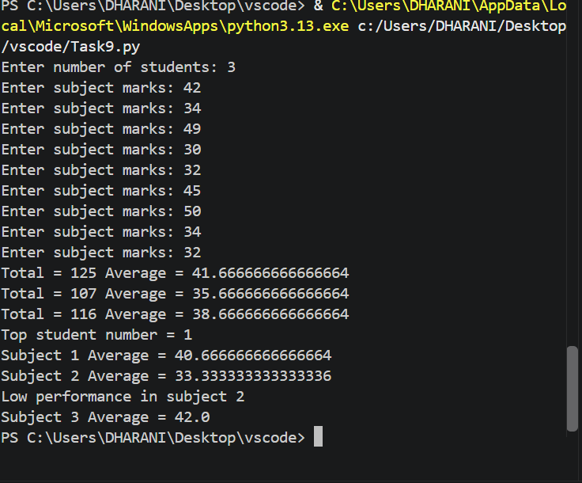

Task-10
Advanced Numeric Pattern Generator: Produce a hollow diamond or symmetric numerical pattern based on user-specified dimensions, with validation for invalid dimensions and carefully aligned output.

1. Algorithm
- Start.
- Input the number of rows n.
- Check whether n <= 0.
  - If yes, display "Invalid number" and stop.
- Generate the upper half of the diamond:
  - For i from 1 to n:
    - Print n - i spaces for alignment.
    - Print numbers from 1 to i.
    - Print numbers from i-1 down to 1.
    - Move to the next line.
- Generate the lower half of the diamond:
  - For i from n-1 down to 1:
    - Print n - i spaces.
    - Print numbers from 1 to i.
    - Print numbers from i-1 down to 1.
    - Move to the next line.
- Stop.

2. Flowchart
┌──────────────┐
│ START │
└──────┬───────┘
│
▼
┌────────────────────┐
│ Enter number of │
│ rows (n) │
└─────────┬──────────┘
│
▼
┌────────────┐
│ n <= 0? │
└─────┬──────┘
Yes │ │ No
│ │
▼ ▼
┌───────────────┐ ┌────────────────┐
│ Print "Invalid│ │ i = 1 │
│ number" │ └───────┬────────┘
└───────┬───────┘ │
│ ▼
│ ┌─────────────┐
│ │ i <= n ? │
│ └──────┬──────┘
│ Yes │ │ No
│ │ │
│ ▼ │
│ ┌──────────────────┐
│ │ Print n-i spaces │
│ └────────┬─────────┘
│ │
│ ▼
│ ┌──────────────────┐
│ │ Print 1 to i │
│ └────────┬─────────┘
│ │
│ ▼
│ ┌──────────────────┐
│ │ Print i-1 to 1 │
│ └────────┬─────────┘
│ │
│ ▼
│ ┌────────────┐
│ │ i = i + 1 │
│ └─────┬──────┘
│ │
│ └──► Repeat
│
│
│ ┌────────────┐
│ │ i = n - 1 │
│ └─────┬──────┘
│ │
│ ▼
│ ┌────────────┐
│ │ i >= 1 ? │
│ └─────┬──────┘
│ Yes│ │No
│ │ │
│ ▼ ▼
│ ┌──────────────────┐
│ │ Print n-i spaces │
│ └────────┬─────────┘
│ │
│ ▼
│ ┌──────────────────┐
│ │ Print 1 to i │
│ └────────┬─────────┘
│ │
│ ▼
│ ┌──────────────────┐
│ │ Print i-1 to 1 │
│ └────────┬─────────┘
│ │
│ ▼
│ ┌────────────┐
│ │ i = i - 1 │
│ └─────┬──────┘
│ │
│ └──► Repeat
│
▼
┌──────────┐
│ STOP │
└──────────┘

3. Pseudocode
BEGIN

INPUT n

IF n <= 0 THEN
DISPLAY "Invalid number"

ELSE

FOR i ← 1 TO n DO

FOR j ← 1 TO n-i DO
DISPLAY " " WITHOUT NEW LINE
END FOR

FOR j ← 1 TO i DO
DISPLAY j WITHOUT NEW LINE
END FOR

FOR j ← i-1 DOWN TO 1 DO
DISPLAY j WITHOUT NEW LINE
END FOR

MOVE TO NEXT LINE

END FOR

FOR i ← n-1 DOWN TO 1 DO

FOR j ← 1 TO n-i DO
DISPLAY " " WITHOUT NEW LINE
END FOR

FOR j ← 1 TO i DO
DISPLAY j WITHOUT NEW LINE
END FOR

FOR j ← i-1 DOWN TO 1 DO
DISPLAY j WITHOUT NEW LINE
END FOR

MOVE TO NEXT LINE

END FOR

END IF

END

4. Test Cases

Test Case 1 — n = 1
Input:
1
Expected output:
1

Test Case 2 — n = 3
Input:
3
Expected output:
1
121
12321
121
1
The pattern is symmetric about the center row.

Test Case 3 — n = 4
Input:
4
Expected output:
1
121
12321
1234321
12321
121
1

Test Case 4 — n = 5
Input:
5
Expected output:
1
121
12321
1234321
123454321
1234321
12321
121
1

Test Case 5 — Invalid Dimension
Input:
0
Expected output:
Invalid number

Test Case 6 — Negative Dimension
Input:
-3
Expected output:
Invalid number

5. Conclusion
The Advanced Numeric Pattern Generator successfully creates a symmetric numerical diamond pattern based on the user-specified number of rows. The program uses nested loops to control spaces and numbers and generates both the upper and lower portions of the pattern. It also validates the input and rejects zero or negative dimensions. This program demonstrates the practical use of nested loops, conditional statements, input validation, number sequences, and output alignment in Python.

6.Programm
n = int(input("Enter number of rows: "))

if n <= 0:
print("Invalid number")
else:
for i in range(1, n + 1):
for j in range(n - i):
print(" ", end="")

for j in range(1, i + 1):
print(j, end="")

for j in range(i - 1, 0, -1):
print(j, end="")

print()

for i in range(n - 1, 0, -1):
for j in range(n - i):
print(" ", end="")

for j in range(1, i + 1):
print(j, end="")

for j in range(i - 1, 0, -1):
print(j, end="")

print()

7.Screenshot
